**ADVANCED SOFTWARE ENGINEERING**

**TUTORIAL -1**

**Installation of softwares:**

**GIT SHELL:**

After the installation of GIT SHELL go into the path of the repository created. (into the master branch).

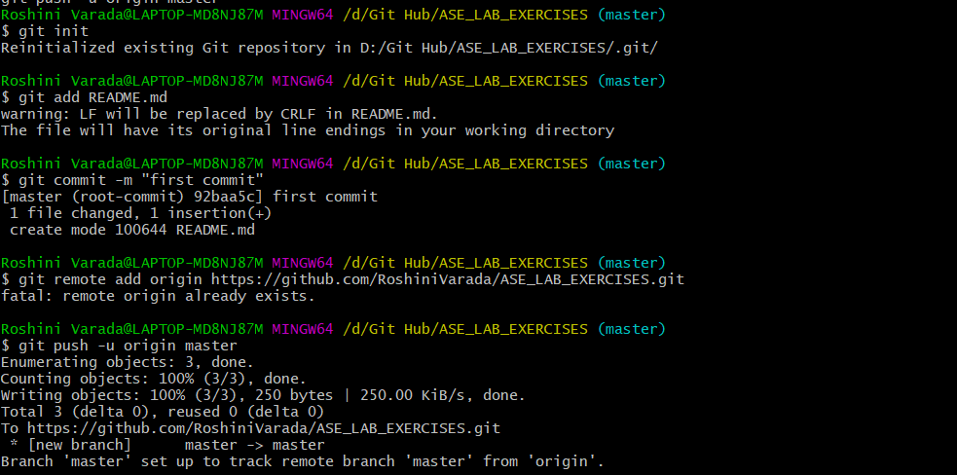

After that “tutorial1” branch is created from the master branch.



After the creation of the branch go into the tutorial created using “$ git checkout tutorial1”



Keep the files that are ready to commit into the tutorial1 using the command “$ git add.”



After that commit the tutorial1 branch to the git.

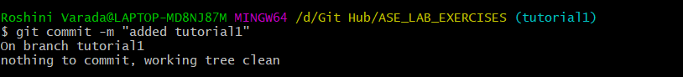

Push the tutorial1 to the git

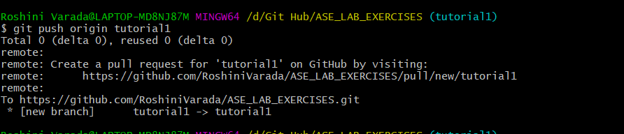

After GIT cloning

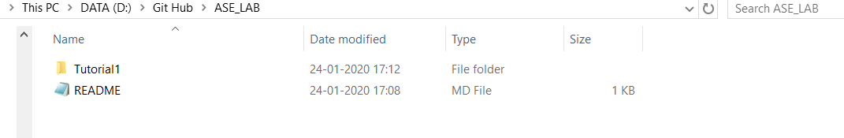

**ZENHUB:**  
Installation of Zenhub:

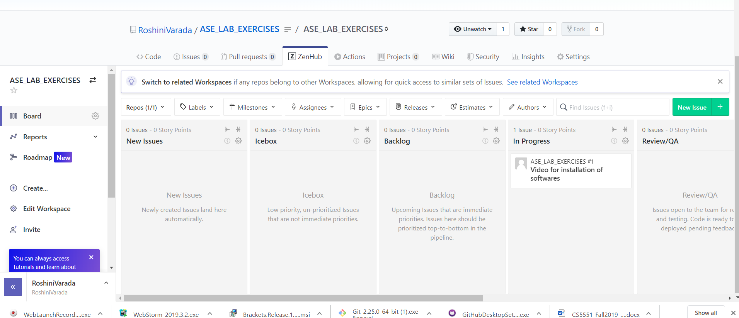

Creation of new issue:

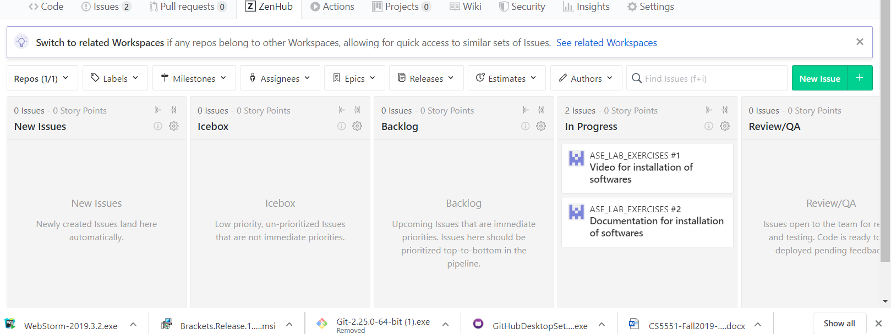

**Creately account:**

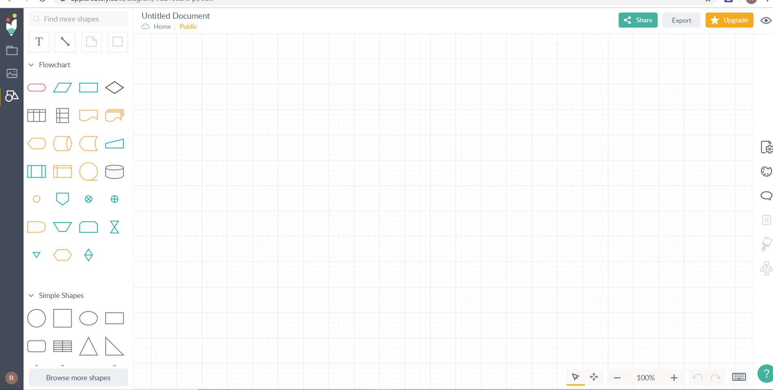

**Webstorm installation:**

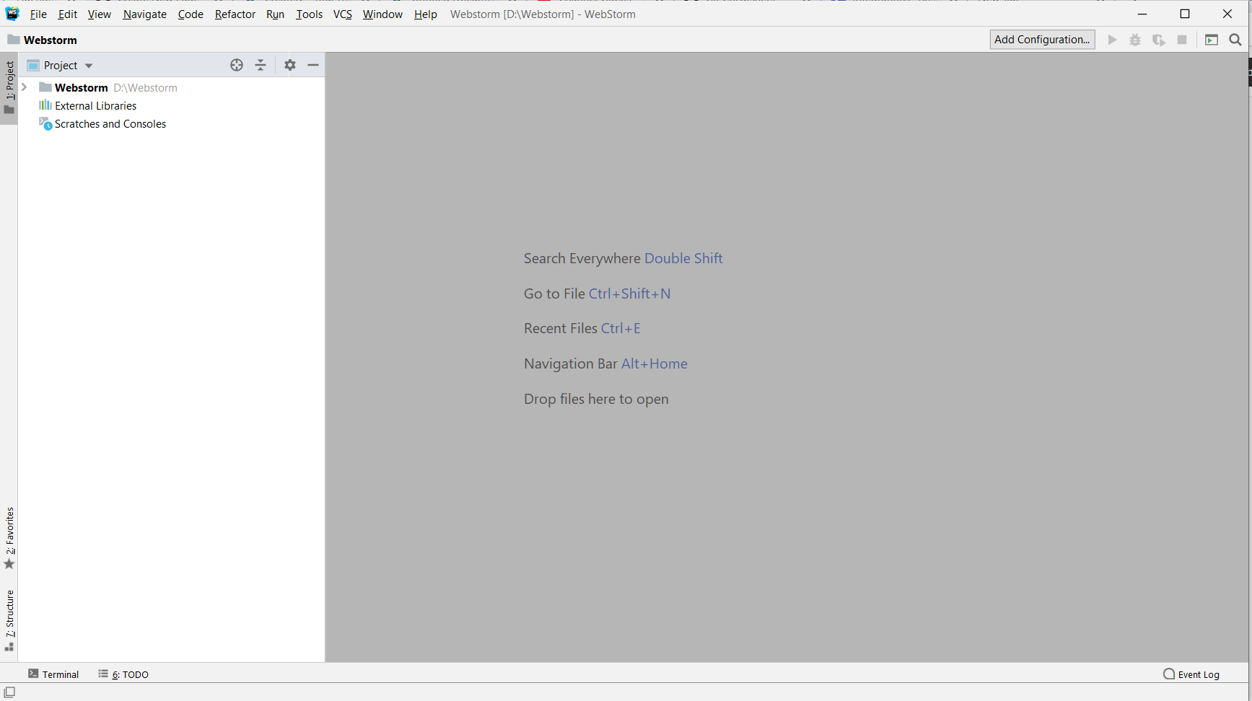

**BRACKETS installation:**

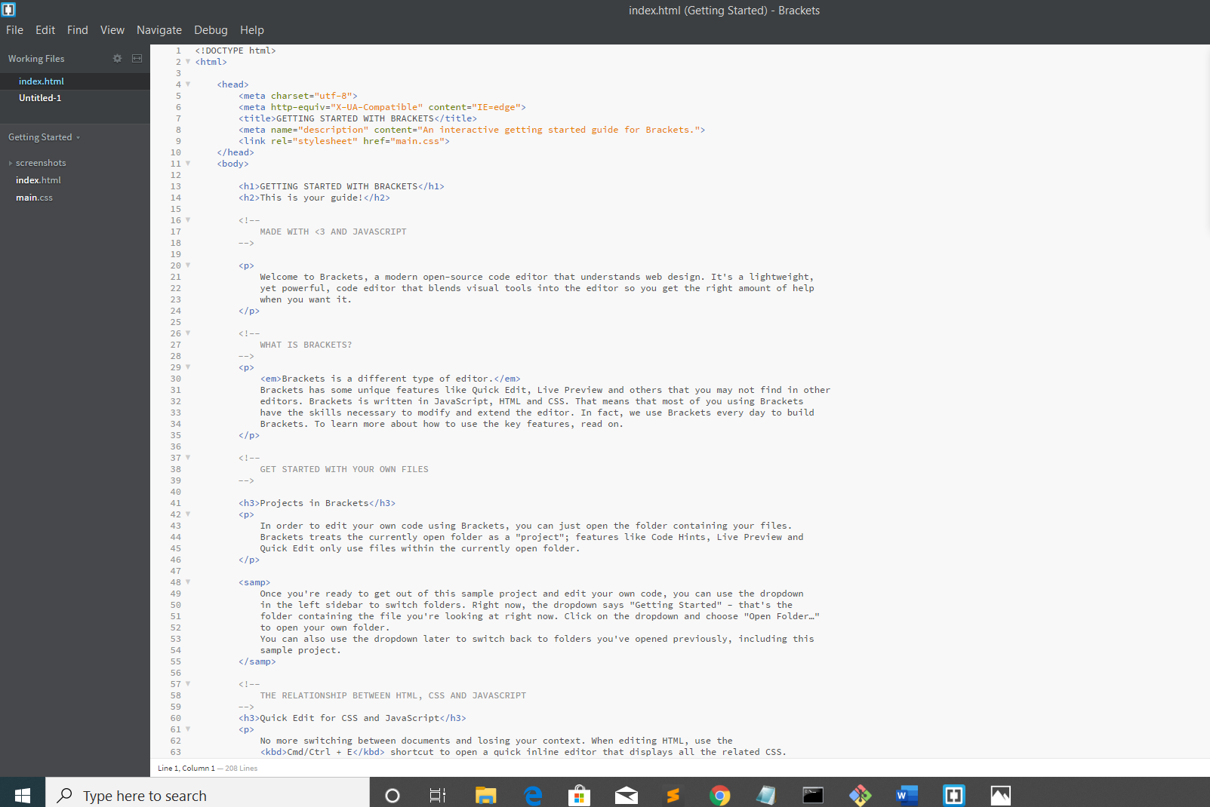

**Ionic, node and NPM installations:**

